1/2/2024

Rudransh Chaturvedi

**Weather Analysis**

Capstone Project

**Project development steps**

**Data Retrieval from GitHub:**

Obtain the required dataset from a specified GitHub repository containing crucial information on university rankings across diverse countries and their performance in various ranking systems.

**MECE and Data transformation:**

MECE is done to explore the data before actual analysis. If necessary, implement data refinement processes to improve data quality and ensure consistency. Additionally, explore opportunities to augment the dataset by introducing new problem statements that can enhance its analytical potential.

**Integration with Analytical Tools:**

Establish seamless connections between the dataset and a variety of analytical tools. Facilitate the smooth integration and processing of data by interfacing the dataset with Power BI, Excel, and MySQL Workbench. This interconnected approach streamlines both data management and analytical workflows.

**Power BI Solutions for Problem Statements:**

Harness the capabilities of Power BI to address the specified problem statements. Leverage its robust tools for data visualization, exploration, and analysis, leading to the discovery of valuable insights and the implementation of effective solutions.

**In-Depth Data Exploration (IDE):**

Conduct a comprehensive exploration of the data using either Excel or SQL Workbench, depending on the complexity of the dataset. Uncover meaningful insights, discern patterns, relationships, and trends within the dataset, providing a solid foundation for informed decision-making.

**Development of Visuals and Informative Presentation:**

Construct a detailed PowerPoint presentation that effectively communicates the project's objectives, methodologies, problem statements, solutions, and key visualizations. Ensure each problem statement is accompanied by a dedicated section highlighting significant conclusions and valuable insights.

**Thorough Documentation:**

Compile a comprehensive report capturing the entire project lifecycle. The report should encompass key sections focusing on data collection, data refinement, problem statement formulation, tool integration, Power BI solution development, insights gained from exploratory data analysis (IDE), and the creation of visualizations using PowerPoint.

**Dataset overview**

The task at hand involves conducting an in-depth analysis of weather trends, seasonal variations, andations between various weather attributes. The dataset provided includes comprehensive information on city attributes, humidity, pressure, temperature, weather descriptions, wind direction, and wind speed for a range of cities.

The dataset is structured in several tables, each serving a specific purpose. The "City_attributes" table contains metadata about each city, including its name, country, latitude, and longitude. This table can be used to map cities to their respective countries and geographical coordinates, making it useful for location-based analysis or visualization on a map.

The "Humidity" table contains hourly data representing the humidity levels in each city, providing insights into humidity trends, seasonal variations, or correlations between humidity and other factors. Similarly, the "Pressure" table offers hourly data about the air pressure levels in each city, which can be used to study pressure patterns, predict weather changes, or understand the relationship between pressure and other weather attributes.

The "Temperature" table contains hourly temperature data for each city, which is vital for studying temperature trends, understanding heatwaves or cold spells, and correlating temperature with factors like energy consumption. The "Weather_description" table provides a textual description of the weather for each city on an hourly basis, offering insights into the qualitative aspects of weather, categorizing weather types, or analysing the frequency of certain weather conditions.

The "Wind_direction" table contains data about the direction from which the wind is blowing on an hourly basis for each city, which can be used to study wind patterns, predict potential wind-related events, or understand the relationship between wind direction and other factors like pollution dispersion. Finally, the "Wind_speed" table provides hourly data about the speed of the wind in each city, which is vital for understanding wind patterns, predicting potential wind-related hazards, or studying the impact of wind speed on various activities.

The ultimate goal is to develop a Power BI dashboard for weather monitoring and historical weather analysis, using Excel and SQL to gain insights and correlations between different weather attributes. This dashboard will enable users to visualize weather trends, seasonal variations, and correlations, providing valuable insights for various industries, including agriculture, energy, transportation, and tourism.

**MECE Analysis**

MECE stands for "mutually exclusive and collectively exhaustive and is a principle used in data analysis to divide data into categories that are distinct from one another and that together cover all possible options. This principle helps to eliminate redundancy and ensure that all relevant data is considered. In the context of data analysis, applying the MECE principle dividing data into non-overlapping categories that, when combined, cover all the data points being analysed. This can help to simplify complex data sets and make it easier to identify patterns and trends.

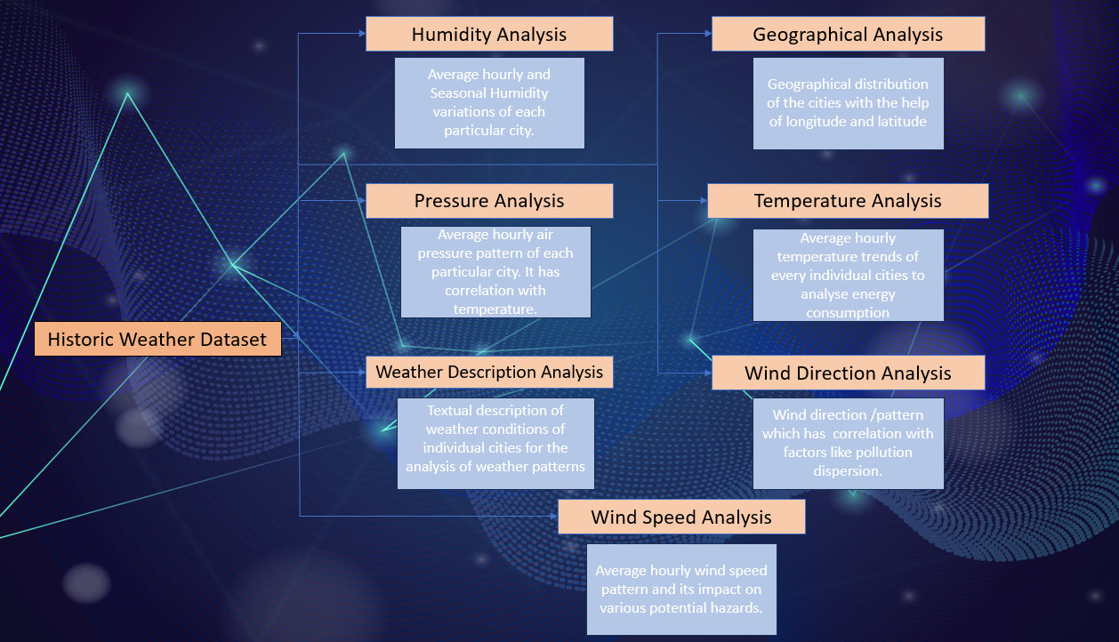

**Introduction:**

* Introduce the purpose and significance of the weather analysis project.
* Highlight the key objectives, including understanding weather patterns, seasonal variations, and correlations between various weather attributes.
* Briefly mention the importance of utilizing Excel, SQL, and Power BI for data analysis and visualization.

**Humidity Analysis:**

* Analyse hourly humidity levels across cities using the Humidity table.
* Identify trends, seasonal variations, and correlations with other weather attributes.
* Discuss potential implications of humidity on weather conditions.

**Pressure Analysis:**

* Explore hourly air pressure data from the Pressure table.
* Investigate pressure patterns and their potential impact on weather changes.
* Examine relationships between pressure levels and other weather attributes.

**Temperature Analysis:**

* Investigate hourly temperature data using the Temperature table.
* Analyse temperature trends, heatwaves, cold spells, and correlations with external factors like energy consumption.
* Discuss the implications of temperature variations on local climates.

**Weather Description Analysis:**

* Utilize the Weather_description table to analyse textual weather descriptions on an hourly basis.
* Categorize weather types, analyse their frequency, and correlate with quantitative weather attributes.
* Discuss the qualitative aspects of weather and potential implications for various activities.

**Wind Direction Analysis:**

* Examine wind direction data from the Wind_direction table on an hourly basis.
* Study wind patterns, predict potential wind-related events, and understand relationships with pollution dispersion.
* Discuss the impact of wind direction on local weather conditions.

**Wind Speed Analysis:**

* Analyse hourly wind speed data from the Wind_speed table.
* Understand wind patterns, predict potential hazards related to wind speed, and study its impact on various activities.
* Correlate wind speed with other weather attributes.

**Geographical Analysis:**

* Summarize the geographical distribution of cities based on latitude and longitude from the City_attributes table.
* Discuss the potential influence of geographical location on weather patterns.
* Integrate geographical insights into other analyses for a comprehensive understanding.
* Conclusion:

**Data Transformation**

To enhance the effectiveness of our data analysis, we propose the creation of five new tables derived from the existing data:

**City_attributes Table:**

This table, named City_attributes, will encompass city_id, country_id, latitude, and longitude, providing essential metadata for each city.

**City_lookup Table:**

The second table, City_lookup, will include the city name and will establish a linkage to City_attributes and final_fact through the city_id, fostering a coherent data structure.

**Country Table:**

The third table, Country, will solely contain the country name, facilitating the mapping of cities to their respective countries, streamlining location-based analyses.

**Date_lookup Table:**

The fourth table, Date_lookup, will be dedicated to date details extracted from the Datetime column in the original tables. This organization enhances data management and ensures a systematic approach to date-related analyses.

**Final_fact Table:**

The fifth table, aptly named Final_fact, emerges as the central fact table housing comprehensive weather attributes such as weather description, temperature, pressure, humidity, wind speed, and wind direction. This table establishes connections to City_attributes, Date_lookup, Country, City_lookup, and Time_lookup.

**Time_lookup Table:**

The sixth and final table, Time_lookup, will exclusively capture time details extracted from the Datetime column in the original tables. This table complements the overall structure, contributing to a well-organized and normalized dataset.

These proposed tables adhere to normalization principles, ensuring consistency and a structured format conducive to efficient data analysis and management. The establishment of relationships between tables through key identifiers enhances the integrity of the dataset, fostering a more coherent and insightful exploration of weather trends and correlations.

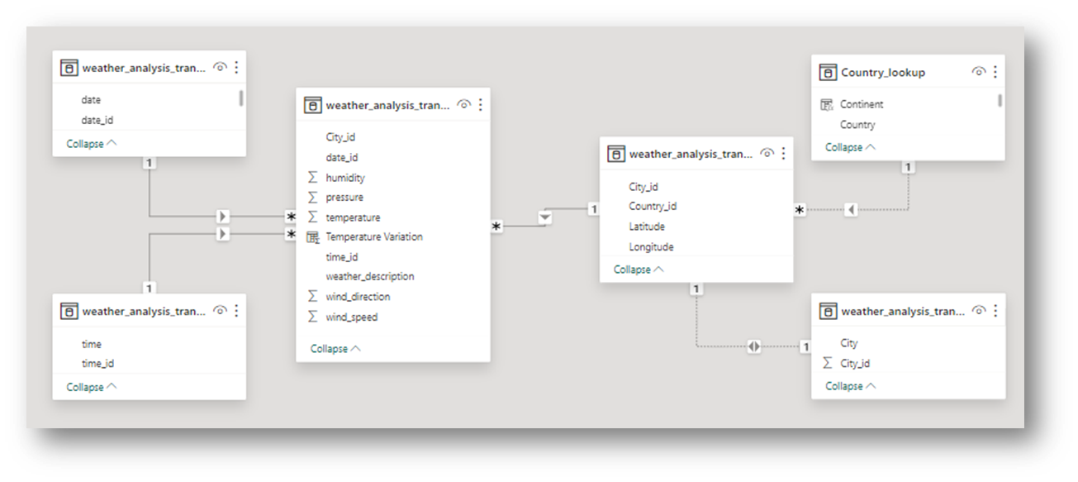

**EDA Problem Statement**

1. **Are there any countries with cities located at extreme latitudes, and how might this impact their climate?**

Firstly, I have extracted data from MySQL having latitude and longitude of the city.

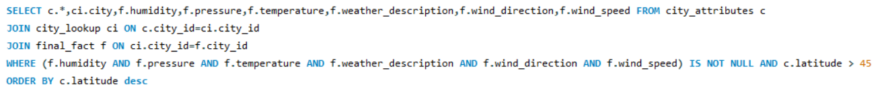

I have made a pivot table to analyse weather/climatic variations with respect to latitudinal position of City/Country.

I have also added slicer for weather description so that it becomes easier for the viewer to see how does the climatic conditions like humidity, pressure, temperature, wind direction and speed results in the weather of the particular place.

In our analysis, we designate countries lying on or above 60 degrees or below -60 degrees of latitude as extreme latitude countries. However, due to a lack of data for such extreme latitudes, we have opted to consider countries situated along the 45-degree latitude lines for our examination.

**Humidity:**

The graphical representation underscores a discernible trend of increasing humidity with higher latitudes. This pattern is notably pronounced in countries positioned at extreme latitudes.

**Pressure:**

In general, the graph illustrates a decrease in air pressure as latitude increases, aligning with established atmospheric patterns. Noteworthy is the anomaly observed in Montreal, where climatic factors beyond latitude may contribute to its deviation from the anticipated trend.

**Temperature:**

The graph vividly portrays a decrease in temperature with increasing latitude, in keeping with the expected climatic patterns. However, Montreal emerges as an exception, suggesting that other climatic factors and its longitudinal location may influence its temperature variations.

**Wind Direction:**

Our analysis reveals a clear trend in which wind direction, measured in degrees, tends to decrease as latitude increases. This consistent pattern is also observable in countries situated at extreme latitudes.

**Wind Speed:**

Latitude demonstrates a limited impact on wind speed, with longitudinal position playing a more significant role. Generally, coastal areas exhibit higher wind speeds. The anomaly in Montreal's higher wind speed can be attributed to its location towards the western part, indicating the influence of local geographical factors.

These insights offer a nuanced understanding of the relationship between latitude and various weather attributes. The exceptions noted in Montreal underscore the multifaceted nature of climatic influences, prompting a more comprehensive exploration beyond latitude in our analysis.

1. **Can you identify any clusters of cities with similar latitude and longitude values? What factors might explain these clusters?**

In response to the inquiry about identifying clusters of cities with similar latitude and longitude values, a comprehensive dataset was retrieved using a MYSQL query. 

The subsequent analysis involved creating visual representations in the form of scatter plot and column graphs to provide a clearer visualization of latitude and longitude values for each country.

To delve deeper into the factors influencing these clusters, considerations extend beyond mere spatial arrangement. Potential explanatory factors encompass geographical regions, climate zones, and tectonic plate boundaries. It is worth noting that while countries may not share exact latitude and longitude values, closely aligned coordinates may signify geographical proximity and potentially similar environmental characteristics.

In conclusion, these visualizations offer valuable insights into the spatial distribution of cities based on latitude and longitude. However, a comprehensive understanding of the clusters necessitates further analysis and domain-specific knowledge, emphasizing the importance of considering additional factors such as regional geography and climate zones for a more nuanced interpretation.

1. **Are there any correlations between a city's geographical location (latitude and longitude) and its weather attributes, such as temperature or humidity?**

In addressing the inquiry regarding correlations between a city's geographical location (latitude and longitude) and its weather attributes, a structured analysis was conducted using correlation formulas. To initiate this investigation, the average values of temperature and latitude were computed, laying the foundation for subsequent correlation calculations.



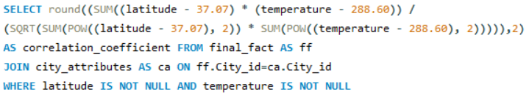

The obtained correlation result of -0.43 between latitude and temperature signifies a moderate negative relationship. This implies that as the latitude increases, there is a corresponding decrease in temperature. This finding aligns with established climatic patterns, as higher latitudes are generally associated with cooler temperatures.

Contrastingly, the correlation of 0.07 between longitude and humidity suggests no discernible direct or indirect influence of longitude on humidity levels. Similarly, the correlation of 0.12 between latitude and humidity also indicates a lack of a direct or indirect relationship between latitude and humidity. These results suggest that geographical longitude and latitude have minimal impact on humidity levels.

Furthermore, the correlation of 0.21 between latitude and temperature suggests no significant direct or indirect effect of longitude on temperature. This finding reinforces the idea that latitude plays a more prominent role in influencing temperature variations compared to longitude.

In summary, the analysis reveals that latitude exhibits a discernible correlation with temperature, with higher latitudes correlating with lower temperatures. However, the correlations between longitude and humidity, as well as latitude and humidity, are negligible, highlighting latitude as the primary geographical factor influencing temperature variations. This nuanced understanding contributes valuable insights into the complex interplay between geographical location and specific weather attributes.

1. **Identify the top three cities with the most frequent occurrence of rainy weather based on weather descriptions. What are the seasonal patterns?**

In response to the investigation into the cities with the most frequent occurrence of rainy weather based on weather descriptions, a meticulous MySQL query was executed to filter and create a new table containing instances where the term 'rain' appeared in the 'weather_description' column. Subsequently, a distinct table was formed, employing the COUNTIF formula to tally the occurrences of rainfall in each city. By ranking these counts in descending order, the top three cities with the highest frequency of rainfall were identified as Portland, Vancouver, and Seattle, respectively.

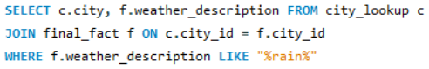

To unravel the seasonal patterns associated with rainfall, a new table was crafted to incorporate year and month details. A pivotal step involved creating a pivot table to capture the count of rainfall occurrences for each city, facilitating a granular analysis of seasonal trends. The integration of slicers further enhanced the visual representation, offering users an intuitive interface to explore monthly and yearly variations in rainfall for each city.

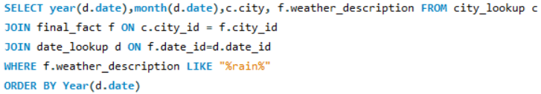

The subsequent generation of a bar graph provided a detailed overview of the monthly rainfall distribution for each city, with slicers offering the flexibility to refine analyses based on specific months and years. Additionally, a pie chart was employed to spotlight the months with the highest and lowest frequency of rainfall across all cities. Slicers for city and year further refined the analysis, enabling users to delve into individual city-specific trends.

From the comprehensive analysis, it is discerned that, on an annual basis, April, October, and May witnessed the highest rainfall, while July, February, and September experienced the least. Taking into account data availability, 2015 emerged as the year with the highest overall rainfall, followed sequentially by 2014, 2016, and 2013. Notably, the years 2012 and 2017 lacked complete data, impacting the overall comparative analysis.

This detailed exploration of rainfall patterns provides valuable insights for better understanding and anticipating the climatic conditions in these cities, contributing to a more informed and data-driven perspective on seasonal variations.

1. **Is there a correlation between humidity levels and air pressure? How might this relationship affect weather conditions?**

In addressing the inquiry concerning the correlation between humidity levels and air pressure, a meticulous analysis was undertaken. The process involved the calculation of average humidity and average air pressure values, laying the groundwork for the subsequent application of the correlation formula.

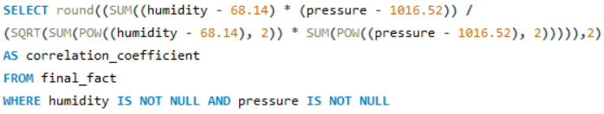

The derived correlation result of 0.08 between humidity and air pressure indicates a weak or negligible relationship. In practical terms, this correlation implies that variations in humidity levels are unlikely to have a substantial impact on predicting or understanding changes in air pressure. The weak correlation suggests that, on average, changes in humidity do not consistently coincide with changes in air pressure.

Understanding this relationship is pivotal for interpreting weather conditions. While humidity and air pressure are both integral components of atmospheric conditions, their weak correlation suggests that variations in one parameter are not inherently linked to variations in the other. This finding underscores the complexity of weather systems, where multiple factors independently contribute to the overall atmospheric state.

In conclusion, the weak correlation between humidity and air pressure highlights the nuanced nature of weather patterns, emphasizing the importance of considering multiple factors for a comprehensive understanding of atmospheric conditions. This information is crucial for meteorological analyses and contributes to refining predictive models for weather forecasting.

1. **Explore the impact of wind direction on temperature for coastal cities. Are there noticeable patterns?**

In the pursuit of unraveling the impact of wind direction on temperature for coastal cities, a targeted approach was adopted to extract and analyze pertinent data. Utilizing a MySQL query, the dataset was strategically grouped based on wind direction, as an exhaustive analysis of the entire dataset would have been impractical due to its extensive size.

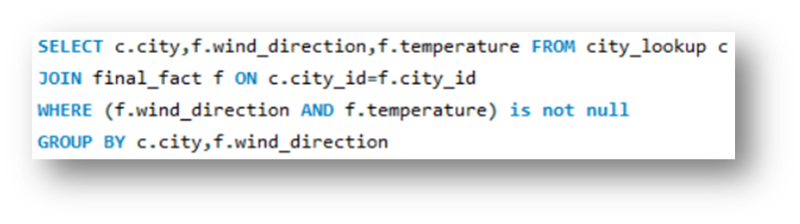

The resulting dataset provided a focused examination of the relationship between wind direction and temperature for coastal cities. The subsequent graphical representation unveiled distinct patterns that shed light on the interplay between these variables.

The analysis distinctly revealed that temperature exhibits a noticeable variation based on wind direction. Specifically, temperatures were observed to be relatively higher when the wind direction fell within the range of 155 to 270 degrees. Conversely, when the wind direction deviated below 140 degrees or exceeded 270 degrees, temperatures tended to be comparatively lower.

It is important to note that this analysis is specific to coastal cities, and the observed patterns may be attributed to the unique climatic influences associated with coastal environments. The utilization of a slicer further enhanced the precision of the analysis by isolating coastal cities, providing a refined understanding of the temperature-wind direction relationship in these specific geographic locations.

In conclusion, the exploration of the impact of wind direction on temperature for coastal cities has yielded insightful observations. The identified patterns contribute valuable knowledge for understanding the climatic dynamics of coastal regions, highlighting the role of wind direction as a key factor influencing temperature variations in these environments.

1. **Are there specific months when cities experience significant temperature fluctuations? What might explain these variations?**

In the pursuit of identifying specific months when cities undergo significant temperature fluctuations, a comprehensive MySQL code was executed to extract temperature data corresponding to particular months for each city. Subsequently, the calculation of temperature variations was performed by subtracting the maximum temperature from the minimum temperature within each selected month.

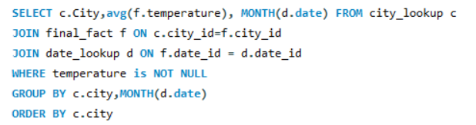

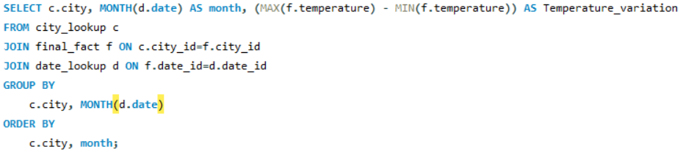

The analysis brought to light that Kansas City exhibited the highest temperature fluctuation, notably in the months of January, February, and December. These particular months stood out as periods characterized by substantial variations in temperature.

Moreover, a broader examination across various cities revealed a recurring pattern where the highest temperature fluctuations were consistently observed in February, January, and December. Conversely, the months of June, July, and August consistently displayed the lowest temperature fluctuations. This consistency in the observed pattern underscores the seasonal influence on temperature variations across diverse geographical locations.

An intriguing observation surfaced when considering coastal cities, such as Miami, Jacksonville, and Houston. These cities demonstrated a distinct trend of experiencing the least temperature fluctuations throughout the year. This unique characteristic may be attributed to the moderating influence of coastal environments, where proximity to large bodies of water helps regulate temperature extremes.

In conclusion, the analysis of temperature fluctuations provides valuable insights into the temporal dynamics of climate across various cities. The identified patterns in specific months and the distinctive behaviour of coastal cities contribute to a nuanced understanding of the factors influencing temperature variations. Such insights are essential for both local and regional climate assessments, enabling better-informed decision-making and resource planning.

1. **Identify periods of extreme weather events, such as storms or heatwaves, by analysing the time-based data. What patterns emerge?**

In the endeavour to identify periods of extreme weather events, specifically storms and heatwaves, a meticulous analysis of time-based data was conducted. For storms, the analysis was facilitated by leveraging the weather description data, providing a clear delineation of storm occurrences. Meanwhile, the identification of heatwaves required a more intricate approach, factoring in temperature and humidity thresholds based on guidelines from the National Weather Service (NWS).

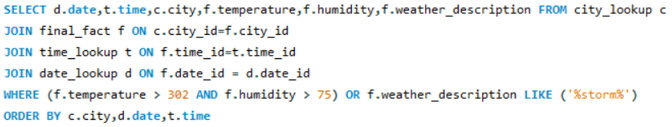

The application of an IF function proved instrumental in categorizing extreme weather conditions, distinguishing between storms and heatwaves. The ensuing graphical representation unveiled notable distinctions in humidity and temperature patterns during storms and heatwaves. It is discerned that humidity levels during storms were significantly lower compared to the elevated humidity levels observed during heatwaves. Similarly, temperatures during storms were comparatively lower than those recorded during heatwaves.

Further exploration into monthly variations showcased distinct patterns. February, December, and January emerged as months with relatively lower temperatures, while March and April exhibited lower humidity levels compared to other months. These insights contribute to a nuanced understanding of the temporal dynamics associated with extreme weather conditions.

A quarterly breakdown revealed noteworthy trends, with Quarter 2 (April, May, June) experiencing higher temperatures, aligning with the onset of warmer seasons. In contrast, December and January stood out with elevated humidity levels, indicating a propensity for increased moisture content during the winter months.

In conclusion, the analysis of extreme weather events, encompassing storms and heatwaves, offers valuable insights into the temporal patterns governing these climatic phenomena. The observed distinctions in humidity and temperature levels during distinct weather events, coupled with monthly and quarterly variations, contribute to a comprehensive understanding of the dynamics shaping extreme weather occurrences. This information proves instrumental for meteorological assessments and aids in formulating strategies for weather-related risk management.

1. **Are there any notable differences in temperature trends between northern and southern hemisphere cities over the year? How do they relate to seasons?**

In the exploration of temperature trends between northern and southern hemisphere cities over the year, a pragmatic approach was adopted, utilizing the equator as the demarcation line at 37.5 degrees latitude. Cities situated above this threshold were classified as part of the northern hemisphere, while those below were designated as southern hemisphere cities.

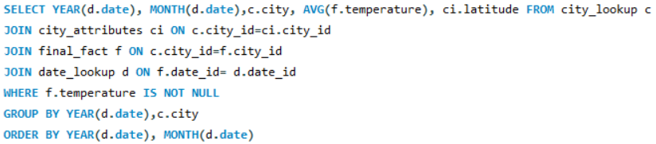

The graphical representation vividly illustrates a conspicuous disparity in average temperatures, with cities in the northern hemisphere consistently exhibiting higher average temperatures compared to their southern hemisphere counterparts. This observed contrast aligns with the geographical positioning, as countries in the southern hemisphere tend to be closer to the equator, experiencing relatively milder climates.

A significant and concerning observation emerged from the analysis—the discernible year-by-year increase in average temperatures. This observation underscores the gravity of global warming, emphasizing its impact on the Earth's climate. The evidence of a consistent temperature rise serves as a stark reminder of the urgent need for global initiatives to address and mitigate the effects of climate change.

Furthermore, the temperature trends are intrinsically linked to the alteration of seasonal patterns. The observed increase in average global temperatures contributes to the transformation of traditional seasonal cycles. Winters are becoming shorter, and summers are intensifying, indicative of a broader shift in seasonal dynamics.

In conclusion, the analysis of temperature trends between northern and southern hemisphere cities not only reveals a notable contrast but also emphasizes the overarching concern of global temperature escalation. This phenomenon not only accentuates the immediate need for climate-conscious actions but also sheds light on the profound impact on seasonal patterns, with potential far-reaching consequences for ecosystems, agriculture, and overall planetary health. Addressing these challenges requires collective and sustained efforts to mitigate climate change and preserve the delicate balance of Earth's climate systems.

1. **What are the consequences of prolonged periods of extreme cold or heat in specific cities? How do residents adapt to such conditions?**

The consequences of prolonged periods of extreme cold or heat in specific cities extend beyond mere climatic discomfort, significantly impacting the well-being and adaptability of residents. A meticulous analysis was conducted, differentiating extreme cold and hot temperatures based on specific thresholds.

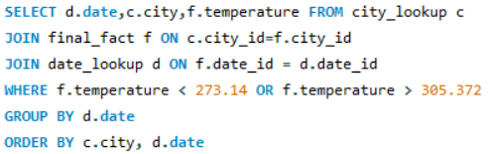

*Consequences of Extreme Cold:*

Health Risks: Prolonged exposure to extreme cold can pose significant health risks, including hypothermia and frostbite. Vulnerable populations, particularly the homeless, are at heightened risk of cold-related health issues.

Increased Energy Consumption: Residents often resort to heightened heating measures during extremely cold periods, leading to increased energy consumption and higher heating costs.

*Adaptations to Extreme Cold:*

Layered Clothing: Residents adapt by donning layered clothing, including thermal wear, to combat the biting cold.

Power Heaters: The use of power heaters, designed to provide additional warmth in living spaces.

Natural Wood Heaters: In some cases, residents turn to traditional methods such as natural wood heaters to generate warmth.

*Consequences of Extreme Heat:*

Heat-Related Illnesses: Prolonged exposure to extreme heat can result in heat-related illnesses, such as heatstroke. Vulnerable populations, including the elderly and infants, are at increased risk of health issues.

Strain on Power Grids: The demand for air conditioning during extreme heat can strain power grids, potentially leading to power outages.

*Adaptations to Extreme Heat:*

Staying Hydrated: Residents adapt by prioritizing hydration, recognizing its crucial role in mitigating the impact of extreme heat.

Air Conditioning Usage: While air conditioning is a common adaptation, it comes with challenges such as higher energy consumption and strain on the electrical grid.

In both extreme cold and heat scenarios, residents employ a range of adaptive measures to safeguard their well-being and cope with challenging climatic conditions. The identification of specific thresholds for extreme temperatures allows for a targeted understanding of the consequences and adaptations relevant to each extreme weather condition. These insights are crucial for urban planning, public health initiatives, and community resilience efforts to address the challenges posed by prolonged periods of extreme cold or heat in specific cities.

1. **Investigate whether temperature anomalies (unusual deviations from the norm) coincide with certain events or environmental factors in specific cities.**

In the investigation of whether temperature anomalies coincide with certain events or environmental factors in specific cities, a meticulous approach was undertaken to extract meaningful insights from the extensive dataset. The analysis involved several steps to calculate and interpret temperature anomalies for each city.

Methodology:

Calculation of Average Temperature: The first step encompassed calculating the average temperature for each city, establishing a baseline for comparison.

Determination of Anomalies: Temperature anomalies were derived by subtracting the average temperature from the observed temperature for each record across various months.

Interpretation of Anomalies: Temperature anomalies signify deviations from the long-term average, providing a quantitative measure of unusual temperature patterns. A negative anomaly indicates temperatures lower than the norm, while a positive anomaly suggests warmer conditions.

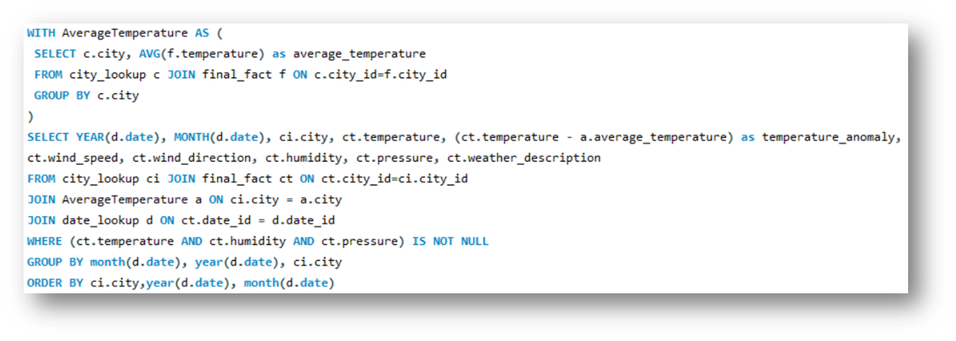

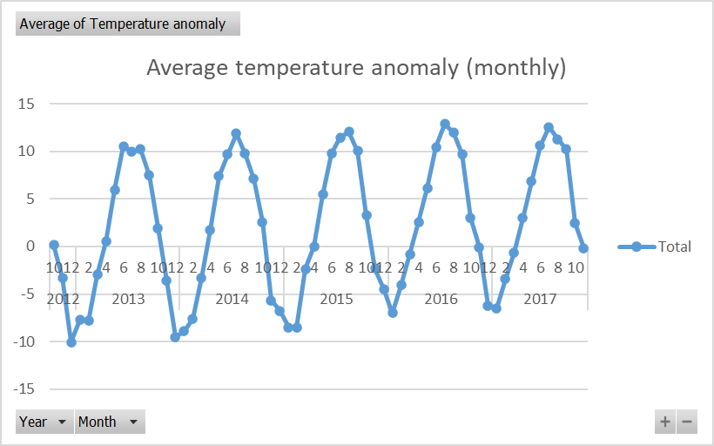

Key Observations:

Monthly Variations: The graphical representation revealed distinct patterns in temperature anomalies across months. January and December exhibited more negative temperature anomalies, suggesting colder-than-usual conditions during these months. Conversely, June, July, and August demonstrated higher positive temperature anomalies, indicative of warmer-than-usual conditions.

Role of Slicer: The incorporation of a slicer in the analysis allowed for a targeted investigation, enabling the identification of specific cities or regions where temperature anomalies were particularly pronounced.

Interpretation:

Investigating temperature anomalies in specific cities serves as a valuable tool to discern unusual temperature patterns. Positive anomalies may be associated with heatwaves or climatic events, while negative anomalies could be linked to cold fronts or unusual atmospheric conditions. The temporal analysis enables a nuanced understanding of the impact of various events or environmental factors on local climate dynamics.

In conclusion, the investigation into temperature anomalies provides a meaningful framework for uncovering abnormal temperature patterns and their potential correlations with specific events or environmental influences. This knowledge can prove instrumental for informed decision-making in urban planning, disaster preparedness, and climate resilience strategies tailored to the unique characteristics of each city.

1. **Analyse the impact of temperature on energy consumption patterns in cities. Are there noticeable trends or correlations?**

In the analysis of the impact of temperature on energy consumption patterns in cities, a discerning approach was adopted to delineate between extreme cold and relatively higher temperature conditions. The categorization was based on specific temperature thresholds, designating extreme cold for readings below 273.14 K and relative heat for temperatures exceeding 299.76 K.

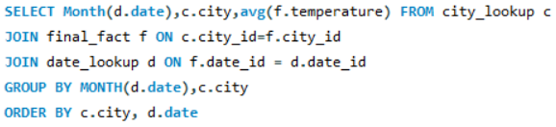

The creation of a new column facilitated the classification of cities into extreme heat and extreme cold categories, providing a comprehensive basis for evaluating energy consumption trends. A meticulous examination of the data, particularly the graph presented below, yielded noteworthy conclusions:

**Key Findings:**

*Energy Consumption Trends:* The graphical representation highlighted distinct patterns in energy consumption trends, particularly during specific months. Notably, January, February, April, May, June, and December emerged as months characterized by heightened energy consumption.

*Temperature-Driven Impact:* Extreme cold temperatures and relatively higher temperatures with high humidity were identified as triggers for increased energy consumption. These climatic conditions necessitate elevated heating or cooling demands, contributing to notable variations in energy consumption patterns.

*Utilization of Slicer:* The incorporation of a slicer further enhanced the analytical framework, allowing for targeted data filtration. This feature aids users in isolating specific temperature categories, providing a more visually intuitive understanding of the correlation between temperature and energy consumption.

**Conclusion:**

The analysis underscores the intricate relationship between temperature variations and energy consumption in cities. The identified months with heightened energy consumption align with periods of extreme temperature conditions, where residents and industries likely increase energy usage for heating or cooling purposes. The insights derived from this analysis have practical implications for energy management strategies, urban planning, and infrastructure development, enabling more informed decision-making to address the seasonal fluctuations in energy demand.

1. **How do specific wind patterns impact air quality and pollution dispersion in urban areas? analyse wind direction data for insights.**

In the examination of specific wind patterns and their impact on air quality and pollution dispersion in urban areas, a focused analysis was conducted leveraging wind direction and speed data for cities experiencing haze and dust. The goal was to discern patterns that shed light on the correlation between wind characteristics and air quality.

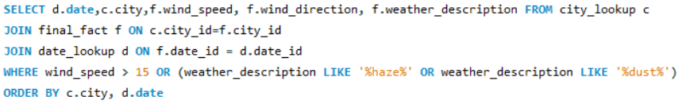

**Key Observations:**

*Wind Speed and Air Quality Index (AQI):* A critical insight emerged from the analysis of wind speed and AQI. Notably, when wind speed remained below 15 km/h, the air quality tended to be poor, indicative of ineffective pollutant dispersion. Conversely, higher wind speeds, exceeding 15 km/h, were associated with improved air quality, suggesting enhanced dispersion of pollutants.

*Wind Direction and AQI:* The directional component of wind also played a pivotal role in influencing AQI. Distinct patterns were observed concerning wind direction in degrees. Specifically, when the wind direction fell within the range of 150 to 220 degrees, the AQI tended to be unfavorable, signifying poorer air quality. Conversely, when wind direction deviated below 130 degrees or exceeded 220 degrees, a noticeable improvement in AQI was evident, indicating better air quality.

**Implications:**

*Pollutant Dispersion:* The findings underscore the significance of wind speed in the dispersion of pollutants. Higher wind speeds contribute to the effective removal of pollutants from the atmosphere, leading to improved air quality.

*Wind Direction's Role:* The directional aspect of wind, as reflected in specific degree ranges, offers nuanced insights. Certain wind directions appear to be associated with less favorable air quality, emphasizing the importance of considering both speed and direction in pollution dispersion.

**Conclusion:**

The analysis illuminates the crucial role of wind patterns, both in terms of speed and direction, in influencing air quality in urban areas with haze and dust. These insights are instrumental for urban planning, pollution control strategies, and public health interventions. By understanding the correlation between wind characteristics and air quality, policymakers and environmental agencies can implement targeted measures to mitigate the impact of pollutants and enhance overall air quality in urban environments.

1. **Identify cities prone to strong winds and the potential consequences, such as increased risk of natural disasters or challenges for transportation.**

In the identification of cities prone to strong winds and the potential consequences, the analysis centered on wind speed data, specifically measured in meters per second (mps). The classification of wind severity was drawn from the Natural Hazard Portal, providing a comprehensive understanding of the potential risks associated with varying wind intensities.

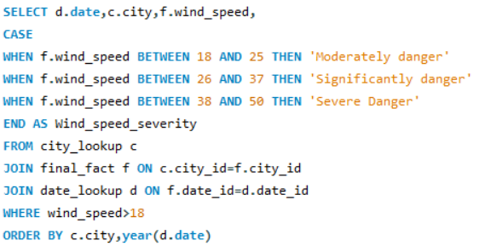

**Key Observations:**

Dangerous Wind Speed Threshold: A threshold of wind speed exceeding 18 mps was established as the criteria for categorizing cities into different levels of wind severity.

**Severity Levels and Consequences:**

*Moderately Dangerous:* Cities falling into this category may experience surface turbulence hindering light aircraft, higher waves on lakes, and toppling of inadequately secured or free-standing objects. Additionally, smaller branches may break.

*Significantly Dangerous:* Cities categorized as significantly dangerous face risks such as falling branches and trees, damage to roofs and individual buildings, disruption to transportation modes, and the potential shutdown of ski lifts and cable cars.

*Severely Dangerous:* Cities in this category are at the highest risk, with potential consequences including falling trees, severe damage to buildings and roofs, significant disruption or restriction of transportation modes, and the possibility of electricity grid outages and telephone network failures.

**Identified Cities with High Wind Speeds:**

*Denver, Dallas, Miami, and Montreal:* These cities were noted for experiencing high wind speeds, presenting a potential risk of moderate danger. While not reaching severe levels, these cities may encounter challenges such as surface turbulence, higher waves, and disruption to traffic and outdoor structures.

*Cities in Israel (Tel Aviv, Jerusalem, Eilat):* Notably, cities in Israel, including Tel Aviv, Jerusalem, and Eilat, demonstrated severe wind intensity. These cities may face severe consequences, including falling trees, building damage, and disruption of transportation.

*USA Cities with Single Instances of Severe Wind:* Cities like San Francisco, Dallas, and Phoenix in the USA experienced occasional severe wind intensity, signifying the potential for severe consequences.

**Conclusion:**

The analysis underscores the importance of identifying cities prone to strong winds and understanding the potential consequences. Such insights are crucial for urban planning, disaster preparedness, and risk mitigation strategies. By recognizing the level of wind severity in specific cities, authorities can implement measures to safeguard infrastructure, enhance transportation resilience, and ensure the safety of residents in the face of adverse wind conditions.

1. **Explore whether wind speed and direction influence the frequency and severity of weather-related events (e.g., hurricanes, storms) in coastal cities.**

In the exploration of whether wind speed and direction influence the frequency and severity of weather-related events, particularly in coastal cities, a detailed analysis was conducted focusing on cities affected by storms or tornadoes. While direct hurricane data was unavailable, insights were gained by examining wind speed and direction patterns in areas experiencing severe weather events.

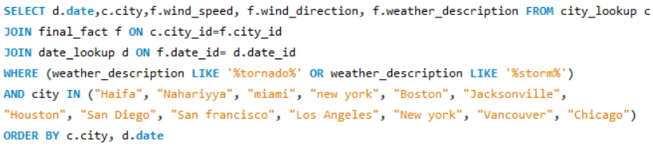

**Key Findings:**

**Wind Speed Patterns in Storm-Affected Coastal Areas:**

Contrary to expectations, the analysis revealed that most coastal cities affected by storms or tornadoes experienced relatively low wind speeds. This unexpected pattern challenges the assumption that higher wind speeds are a direct correlate of severe weather events.

**Wind Direction Patterns in Storm-Affected Coastal Areas:**

The examination of wind direction patterns indicated a commonality among coastal cities. Many of these cities exhibited wind directions of either 0 degrees or more than 120 degrees. However, the diversity in wind direction was noted, highlighting the influence of longitudinal and latitudinal positioning.

**Limitations in Drawing Conclusive Patterns:**

The analysis acknowledged the limitations in drawing conclusive patterns for wind direction. The intricate relationship between wind direction, geographical positioning, and local atmospheric conditions makes it challenging to establish a universal pattern applicable to all coastal cities.

**Conclusion:**

Contrary to conventional expectations, the analysis of wind speed and direction in coastal cities affected by storms or tornadoes revealed unexpected patterns. The prevalence of comparatively low wind speeds challenges the assumption that higher wind speeds are indicative of severe weather events. Additionally, the diversity in wind direction, influenced by geographical factors, underscores the complexity of drawing universal conclusions.

The findings suggest that while wind speed and direction play a role in weather-related events, they do not solely determine the frequency and severity of such events. Other factors, including atmospheric conditions, geographical positioning, and local topography, contribute to the overall dynamics of weather-related phenomena in coastal areas.

This nuanced understanding is vital for improving weather prediction models, enhancing disaster preparedness strategies, and informing urban planning initiatives to mitigate the impact of severe weather events in coastal regions.

**PowerBI Problem analysis**

* **Can you create a geographical map in Power BI showing the distribution of cities in the dataset based on their latitude and longitude?**

In Power BI, I utilized the geographical map visualization to visually represent the distribution of cities based on their latitude and longitude. The map provides an intuitive way to visualize the geographic spread of cities, enabling users to explore the dataset spatially.

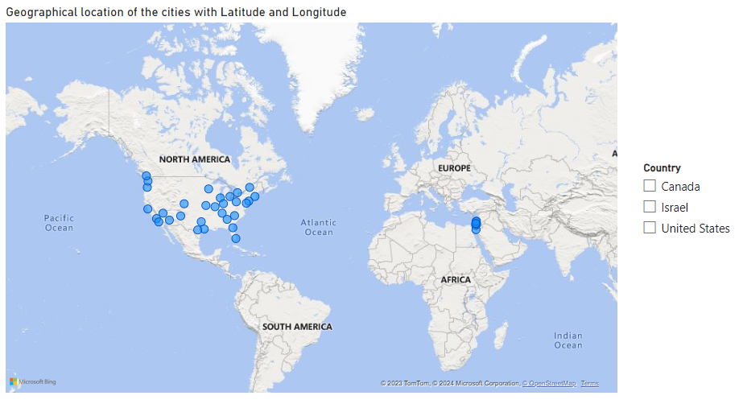

The geographical map in Power BI serves as a dynamic and interactive tool for visualizing the spatial distribution of cities. Users can navigate and explore the dataset based on latitude and longitude coordinates.

The inclusion of a country slicer enhances the user experience by allowing them to selectively view cities from specific countries, providing a more targeted and detailed analysis.

This visualization is instrumental for location-based analysis and offers insights into the global distribution of weather-related data.

* **In Power BI, can you create a bar chart representing the top 10 countries with the highest number of cities in the dataset?**

I created a bar chart to represent the top 10 countries with the highest number of cities in the dataset. Additionally, a pie chart was employed to visually display the percentage distribution of cities across different countries. A table was also incorporated to present the numerical details in a tabular format.

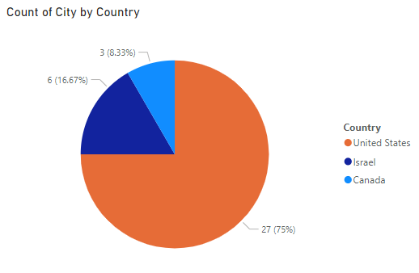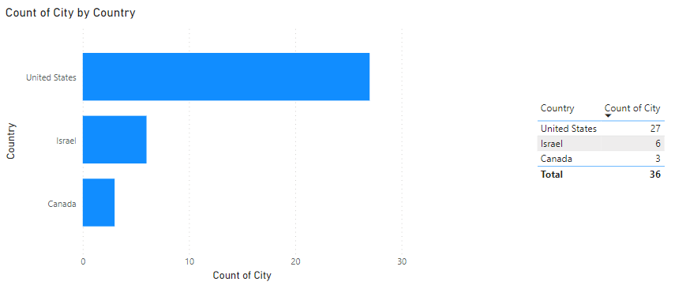

The bar chart in Power BI effectively highlights the top 3 countries with the highest number of cities, providing a quick visual overview of the dataset's geographic distribution. (We don’t have 10 countries in dataset).

The pie chart complements the bar chart by offering a percentage-based representation of city distribution, allowing users to grasp the relative contribution of each country to the dataset.

**Conclusion:**

By incorporating these visualizations and the table, powerBI facilitates a comprehensive exploration of city distribution across different countries, enhancing the user's ability to derive insights from the dataset efficiently.

* **How does the distribution of cities in terms of latitude vary across different continents? Create a scatter plot in Power BI to illustrate this.**

A comprehensive analysis of the distribution of cities based on latitude across different continents was conducted. To facilitate this exploration, a new column named 'Continent' was created using an IF statement, categorizing cities into their respective continents. A slicer was implemented to allow users to interactively explore cities by continent. The primary visualizations employed for this analysis were a scatter plot and a map.

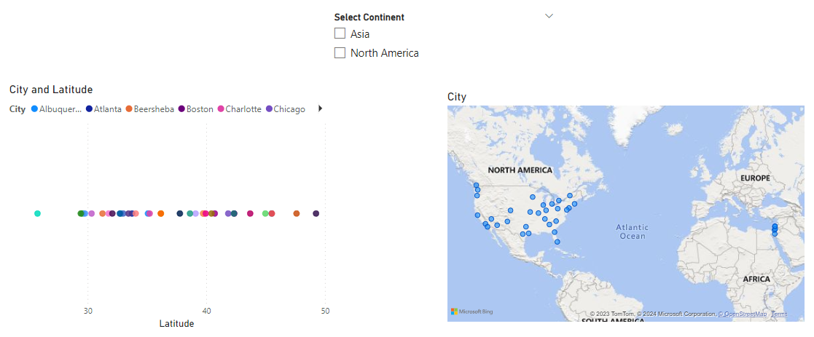

**Key Steps in the Analysis:**

*Continent Categorization:*

Created a new column, 'Continent,' using an IF statement to assign each city to its corresponding continent based on geographical coordinates.

*Slicer Implementation:*

Integrated a slicer based on the 'Continent' column to enable users to filter cities by continent, enhancing the interactive exploration of the dataset.

*Scatter Plot - Latitude Distribution:*

Developed a scatter plot visualization, with latitude on the y-axis, to illustrate the distribution of cities across different continents. Each point on the scatter plot represents a city, providing insights into latitude variations.

*Map Visualization:*

Utilized a map visualization to complement the scatter plot, offering a spatial representation of city distribution across continents. The map enhances the geographical understanding of latitude variations.

**Conclusion:**

By combining the 'Continent' slicer with scatter plot and map visualizations, it provides users with a versatile and interactive platform to explore the distribution of cities in terms of latitude across different continents. This approach enhances the user experience, enabling a more insightful and geographically contextualized analysis of the dataset.

* **Create a line chart in Power BI to display the temperature trends over time for a selected city. Highlight extreme temperature events.**

A detailed analysis of temperature trends over time for a selected city was conducted, with a focus on highlighting extreme temperature events. The primary visualization used for this analysis was a line chart, complemented by a slicer for city selection and additional line graphs to emphasize extreme temperature events.

**Key Steps in the Analysis:**

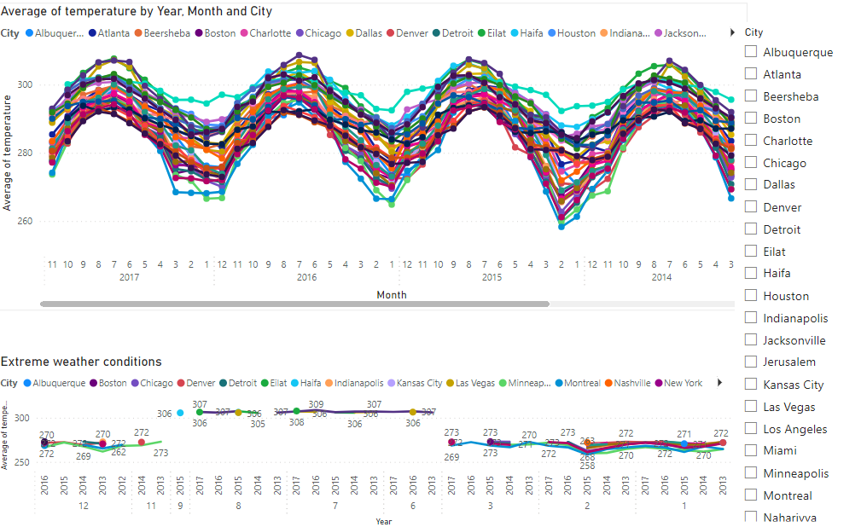

*Line Chart - Average Temperature Trends:*

Created a line chart displaying the average temperature per month over time.

Utilized the 'Date' column (Month and Year) on the x-axis and the 'Temperature' column on the y-axis to showcase temperature trends.

*Slicer for City Selection:*

Implemented a slicer to allow users to dynamically select the city of interest, enhancing the flexibility of the analysis and enabling users to focus on specific locations.

*Additional Line Graphs - Extreme Temperature Events:*

Introduced supplementary line graphs to highlight extreme temperature events.

Identified extreme conditions by filtering temperatures greater than 305.372 K (extreme heat) or less than 273.14 K (extreme cold).

These additional line graphs provide a visual representation of months with commonly extreme temperature events.

**Conclusion:**

By combining the line chart, slicer for city selection, and additional line graphs for extreme temperature events, it offers users a comprehensive and interactive platform to explore temperature trends for a selected city. This approach enables users to gain insights into average temperature patterns and identify months with extreme conditions, fostering a deeper understanding of the temperature dynamics over time.

* **How does humidity vary across different cities? Generate a heatmap in Power BI to visualize this variation.**

A comprehensive analysis of humidity variation across different cities was conducted, utilizing various visualizations to enhance insights. The primary visualizations employed for this analysis were a map, a clustered bar chart, a slicer for country selection, and a gauge for additional insights.

**Key Steps in the Analysis:**

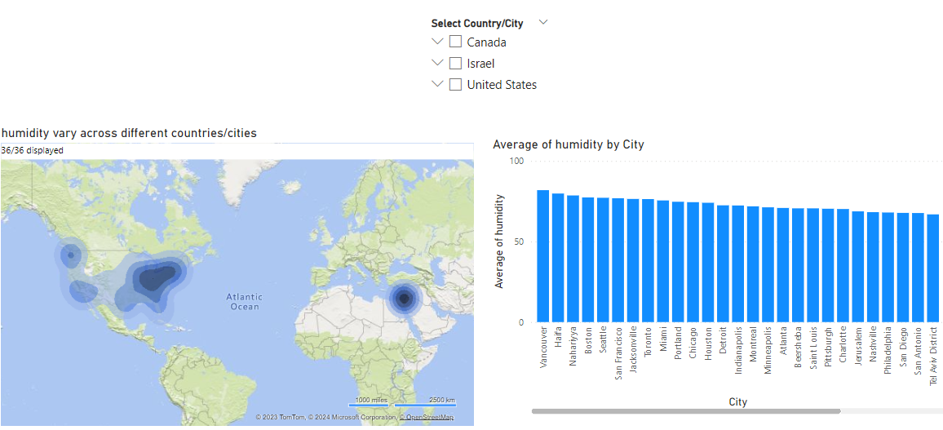

*Map Visualization - Humidity Distribution:*

Utilized a map visualization to represent humidity distribution across different cities.

Mapped the cities on the basis of latitude and longitude, with color intensity indicating the average humidity levels.

*Clustered Bar Chart - City and Average Humidity Relationship:*

Created a clustered bar chart to depict the relationship between cities and their average humidity levels.

The chart provides a comparative view of humidity levels across different cities, aiding in the *identification of variations.*

*Slicer for Country Selection:*

Implemented a slicer to allow users to dynamically select a specific country.

This slicer enhances user interactivity, enabling users to focus on the humidity variation within a particular country.

*Gauge Visualization - Average Humidity Insights:*

Incorporated a gauge visualization to offer additional insights into average humidity levels.

When a user selects a country on the slicer, the gauge dynamically displays the average humidity of the selected city, providing a focused and localized view.

**Conclusion:**

By combining the map, clustered bar chart, slicer for country selection, and gauge visualizations, it provides users with a comprehensive and interactive platform to explore humidity variation across different cities. This approach facilitates a nuanced understanding of humidity patterns, allowing users to gain insights into spatial, comparative, and localized aspects of humidity distribution.

* **Can you create a time-series chart in Power BI showing the relationship between wind speed and air pressure for a specific city?**

A focused analysis of the relationship between wind speed and air pressure for a specific city was conducted using a time-series line chart and a correlation scatter chart. These visualizations provide insights into how wind speed and air pressure vary over time and reveal potential relationships between the two variables.

**Key Steps in the Analysis:**

*Time-Series Line Chart - Wind Speed and Air Pressure:*

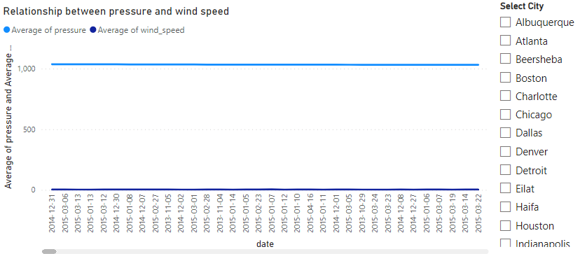

Developed a time-series line chart to illustrate the variations in both wind speed and air pressure over time for the chosen city.

Utilized the 'Datetime' column on the x-axis, 'Wind Speed' on one y-axis, and 'Air Pressure' on the other y-axis to showcase the temporal relationship.

*Correlation Scatter Chart - Relationship Visualization:*

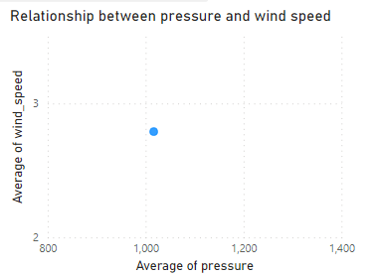

Created a correlation scatter chart to visually represent the relationship between average wind speed and air pressure.

Plotted average wind speed on the x-axis and air pressure on the y-axis, with each point representing a specific time period.

**Conclusion:**

The time-series line chart offers a dynamic view of how wind speed and air pressure fluctuate over time for the selected city, providing insights into temporal patterns. The correlation scatter chart visually represents the correlation between wind speed and air pressure. Each point on the scatter chart signifies a specific time, allowing users to discern potential trends or correlations.

* **Create a time-series line chart in Power BI to show the overall temperature trends over the entire dataset.**

a comprehensive analysis of overall temperature trends over the entire dataset was conducted using a time-series line chart. The line chart was configured to showcase temperature trends per hour, with additional slicers for city and year/month selection, offering users an interactive and detailed exploration of temperature patterns.

**Key Steps in the Analysis:**

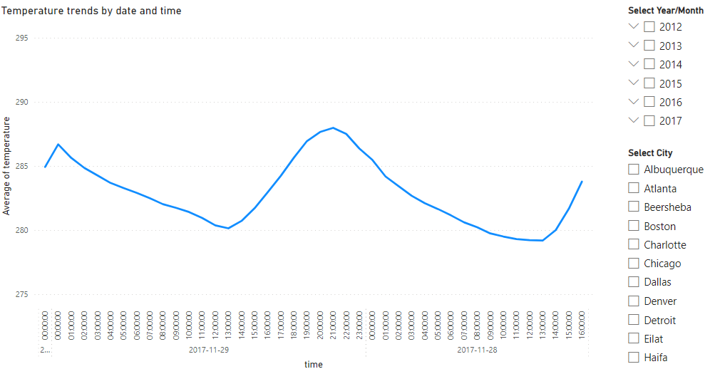

*Time-Series Line Chart - Overall Temperature Trends:*

Developed a time-series line chart to depict the overall temperature trends across the entire dataset.

Utilized the 'Datetime' column on the x-axis and 'Temperature' on the y-axis to showcase temperature variations per hour.

*Slicers for City and Year/Month Selection:*

Implemented slicers to allow users to dynamically select a specific city and narrow down the analysis to a particular year/month.

The slicers enhance user interactivity, enabling users to focus on temperature trends within specific cities and timeframes.

**Conclusion:**

The time-series line chart serves as a comprehensive tool for visualizing temperature trends over the entire dataset, offering insights into hourly variations.

The slicers for city and year/month selection provide users with the flexibility to tailor the analysis to specific locations and timeframes, facilitating a more targeted exploration.

* **Can you create a heatmap in Power BI to visualize the busiest hours for specific weather conditions (e.g., "clear sky," "rainy")?**

an insightful analysis of the busiest hours for specific weather conditions was conducted using a heatmap. The heatmap was designed to visualize the frequency of specific weather conditions, such as "clear sky" or "rainy," across different cities and hours. Additionally, slicers for time and weather description were applied to provide users with an interactive and focused exploration of weather patterns.

**Key Steps in the Analysis:**

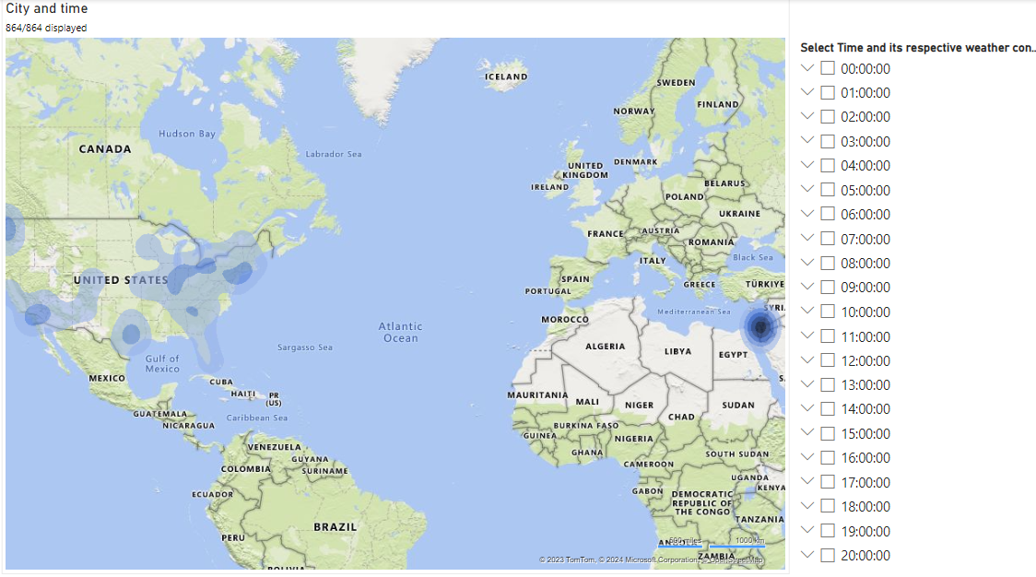

*Heatmap Visualization - Busiest Hours for Weather Conditions:*

Implemented a heatmap visualization to illustrate the frequency of specific weather conditions during different hours across various cities.

Utilized the 'City' dimension on the y-axis, the 'Datetime' dimension on the x-axis, and colour intensity to represent the frequency of weather conditions.

*Slicers for Time and Weather Description:*

Applied slicers to enable users to dynamically select a specific time range and filter the heatmap based on desired weather conditions.

The slicers enhance user interactivity, allowing users to focus on particular hours and weather descriptions.

**Conclusion:**

The heatmap serves as a powerful tool for visualizing the busiest hours for specific weather conditions, offering a comprehensive view of how weather patterns vary across cities and time.

The slicers for time and weather description provide users with the flexibility to customize the analysis, enabling a more targeted exploration of weather conditions during specific hours.

* **How does the wind speed change over the course of a day? Create a radial chart in Power BI to represent this.**

A detailed analysis of how wind speed changes over the course of a day was conducted using a radial chart. The radial chart was designed to represent the average wind speed at different hours, providing a visual depiction of the daily variation. Additionally, a treemap was utilized to showcase the average wind speed by city, offering insights into city-wise wind patterns. A slicer was incorporated to allow users to select specific year/month/date for a more focused exploration.

**Key Steps in the Analysis:**

*Radial Chart - Wind Speed Variation Over the Day:*

Created a radial chart to illustrate the average wind speed at different hours throughout the day.

Utilized the 'Hour' dimension for the radial axis and the 'Average Wind Speed' measure for the circular axis to showcase the hourly variation in wind speed.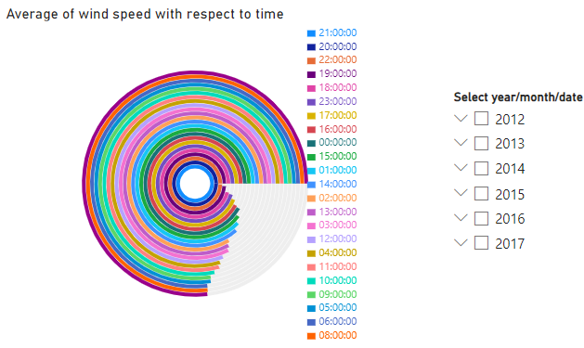

*Treemap Visualization - City-wise Wind Speed Patterns:*

Implemented a treemap to visualize the average wind speed for each city.

Utilized the 'City' dimension and color intensity to represent the average wind speed, allowing users to compare wind patterns across cities.

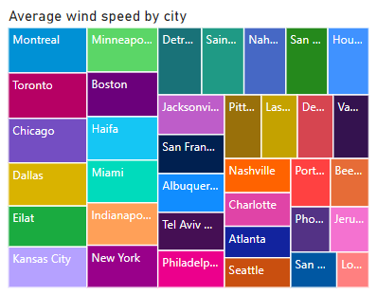

*Slicer for Year/Month/Date Selection:*

Applied a slicer to enable users to dynamically select a specific year, month, or date and filter the radial chart and treemap accordingly.

The slicer enhances user interactivity, allowing for a more targeted exploration of wind speed patterns.

**Conclusion:**

The radial chart provides a unique and intuitive representation of how wind speed changes over the course of a day, offering insights into hourly variations.

The treemap enables users to compare average wind speeds across different cities, providing a city-wise perspective on wind patterns.

* **Create a Power BI chart comparing the temperature variations between two selected cities over a specific timeframe.**

A comprehensive analysis of temperature variations between two selected cities, Charlotte and Dallas, over a specific timeframe was conducted using various chart types. The analysis included a time-series line chart, a bar graph, and a column graph to provide a multi-faceted comparison of temperature trends.

**Key Features:**

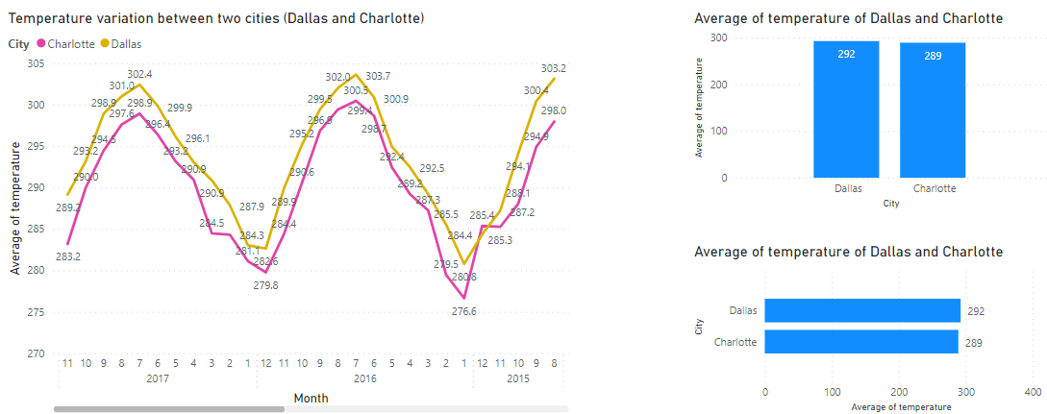

*Time-Series Line Chart - Average Temperature Trends:*

Developed a time-series line chart to compare the average temperature trends between Charlotte and Dallas over the selected timeframe.

Utilized the 'Month' dimension on the x-axis, the 'Average Temperature' measure on the y-axis, and separate lines for each city to showcase monthly temperature variations.

*Bar Graph - Monthly Temperature Comparison:*

Created a bar graph to visually compare the average temperatures of Charlotte and Dallas for each month within the specified timeframe.

Utilized the 'Month' dimension on the x-axis, the 'Average Temperature' measure on the y-axis, and different colored bars for each city to highlight the monthly temperature variations.

*Column Graph - Temperature Comparison by City:*

Implemented a column graph to provide a summarized comparison of average temperatures for Charlotte and Dallas over the selected timeframe.

Utilized two columns representing each city, with color-coding to distinguish between Charlotte and Dallas, offering a concise overview of temperature variations.

**Conclusion:**

The time-series line chart offers a detailed view of how average temperatures vary between Charlotte and Dallas on a monthly basis, providing insights into seasonal patterns.

The bar graph allows users to compare the average temperatures of the two cities for each month, offering a visual representation of temperature variations.

The column graph provides a summarized comparison, allowing users to quickly identify temperature differences between Charlotte and Dallas.

* **Can you build a heatmap in Power BI to show the temperature ranges for cities across different countries?**

A detailed analysis of temperature ranges for cities across different countries was conducted using a heatmap. The heatmap was designed to showcase the average temperature for each city, with additional features such as KPI (Key Performance Indicator) cards, slicers for temperature ranges, and a slicer for city selection to provide users with an interactive and insightful exploration.

**Key Features:**

*Heatmap Visualization - Average Temperature Ranges:*

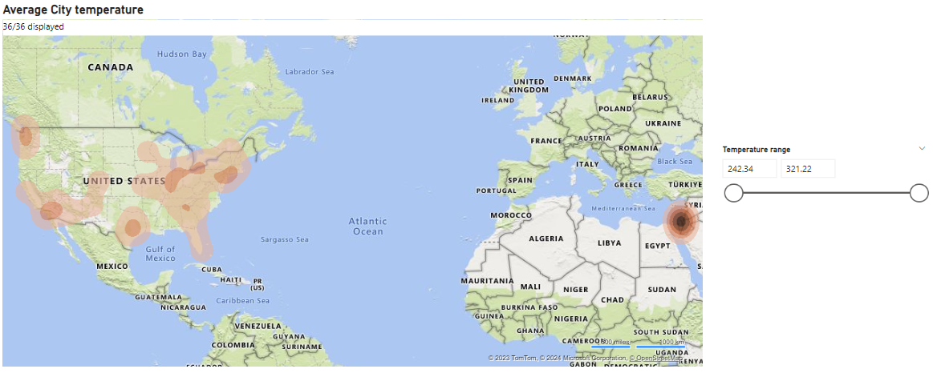

Developed a heatmap to illustrate the average temperature for cities across different countries.

Utilized the 'City' dimension on the rows, the 'Country' dimension on the columns, and color intensity to represent the average temperature, allowing users to identify temperature ranges.

*KPI Cards - Key Performance Indicators:*

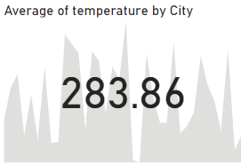

Integrated KPI cards to display key indicators such as the highest and lowest temperatures, providing users with quick insights into temperature extremes.

*Slicers for Temperature Ranges and City Selection:*

Implemented slicers to enable users to dynamically select temperature ranges and filter the heatmap based on specific temperature criteria.

Additionally, incorporated a slicer for city selection, allowing users to focus on the temperature patterns of a particular city.

**Conclusion:**

The heatmap offers a comprehensive overview of average temperatures for cities across different countries, providing a visual representation of temperature variations.

KPI cards serve as quick-reference indicators, displaying the highest and lowest temperatures within the dataset for added context.

Slicers enhance user interactivity, allowing for a dynamic exploration of temperature ranges and enabling users to focus on specific cities of interest.

* **Create a bar chart in Power BI to highlight cities with the highest and lowest average temperatures in the dataset.**

A focused analysis on cities with the highest and lowest average temperatures was conducted using a bar chart. The bar chart was designed to highlight cities based on their average temperatures, with specific graphs showcasing the city with the highest average temperature, the city with the lowest average temperature, and a comprehensive bar chart in descending order of average temperatures.

**Key Features of the Power BI Bar Chart:**

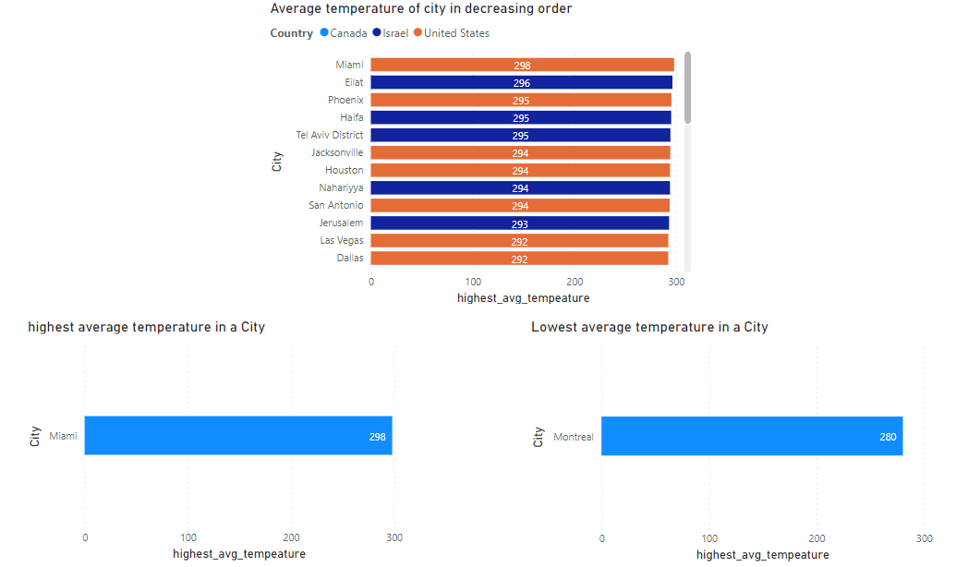

*Bar Chart in Descending Order - Highest Average Temperatures:*

Developed a bar chart displaying cities in descending order based on their average temperatures.

Utilized the 'City' dimension on the x-axis, the 'Average Temperature' measure on the y-axis, and color-coding to emphasize temperature differences.

*Bar Chart - City with the Highest Average Temperature (Miami):*

Created a separate bar chart to specifically highlight the city with the highest average temperature, which is Miami.

Utilized the 'City' dimension on the x-axis, the 'Average Temperature' measure on the y-axis, and distinctive coloring for visual emphasis.

*Bar Chart - City with the Lowest Average Temperature (Montreal):*

Developed another bar chart to focus on the city with the lowest average temperature, which is Montreal.

Utilized the 'City' dimension on the x-axis, the 'Average Temperature' measure on the y-axis, and color differentiation to draw attention to the minimum temperature.

**Conclusion:**

The bar chart in descending order provides a comprehensive overview of cities based on their average temperatures, allowing users to identify the hottest cities at a glance.

The individual bar charts for Miami and Montreal offer detailed insights into the specific cities with the highest and lowest average temperatures, respectively.

* **Create a wind rose chart in Power BI to visualize the prevailing wind directions for a selected city.**

A wind rose chart was generated to visualize the prevailing wind directions for a selected city. Two types of radial charts, specifically a radial graph and a radar graph, were employed to effectively represent the wind rose chart.

**Key Features:**

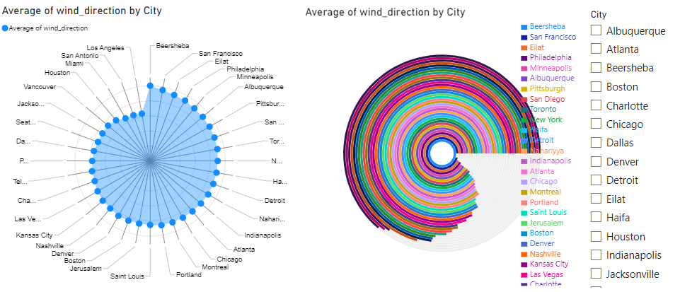

*Radial Graph - Wind Rose Chart:*

Developed a radial graph to illustrate the prevailing wind directions for the selected city.

*Radar Graph - Wind Rose Visualization:*

Implemented a radar graph as an alternative representation of the wind rose chart, providing users with an additional perspective.

**Conclusion:**

The wind rose chart, presented through both radial and radar graphs, offers users an intuitive and visual understanding of prevailing wind directions for the selected city.

Wind directions are represented as segments around the central axis, with the length or area of each segment indicating the frequency of occurrences for that specific wind direction.

* **Can you generate a Power BI heatmap illustrating the average wind speeds across cities for different months of the year?**

An insightful analysis of average wind speeds across cities for different months of the year was conducted using a heatmap. The heatmap was designed to showcase the variations in average wind speeds, with a specific focus on different cities and months. Additionally, a slicer was implemented to allow users to explore the data for different years, enhancing the interactivity and depth of the analysis.

**Key Features of the Power BI Heatmap:**

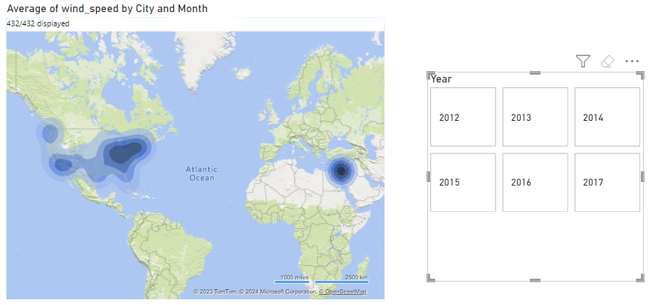

*Heatmap Visualization - Average Wind Speeds:*

Developed a heatmap to illustrate the average wind speeds for various cities across different months of the year.

Utilized the 'City' dimension on the rows, the 'Month' dimension on the columns, and color intensity to represent average wind speeds.

*Slicer for Year Selection:*

Implemented a slicer to enable users to dynamically select different years and observe how average wind speeds vary across cities each month for the chosen year.

**Conclusion:**

The heatmap provides a comprehensive overview of average wind speeds, allowing users to identify patterns and variations for different cities over the course of the year.

The slicer enhances user interactivity, enabling the exploration of average wind speeds for specific years and facilitating a more targeted analysis.

* **Create a Power BI scatter plot to show the relationship between wind speed and air pressure for a specific city.**

a scatter plot chart was generated to visually represent the relationship between wind speed and air pressure for a specific city. The scatter plot offers an effective way to observe patterns and correlations between these two weather attributes, providing a clear visualization of their relationship.

**Key Features:**

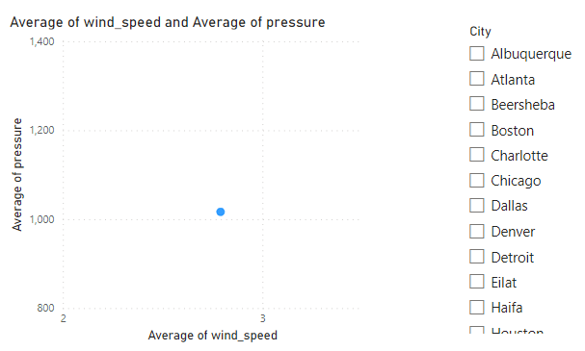

*Scatter Plot Visualization - Wind Speed vs. Air Pressure:*

Developed a scatter plot chart to showcase the relationship between wind speed and air pressure for the selected city.

Utilized the 'Wind Speed' measure on the x-axis, the 'Air Pressure' measure on the y-axis, and data points representing individual observations for the chosen city.

*Slicer for City Selection:*

Implemented a slicer to allow users to select the specific city for which they want to explore the relationship between wind speed and air pressure.

**Conclusion:**

The scatter plot chart provides a visual representation of the correlation between wind speed and air pressure for the selected city, allowing users to identify trends and patterns.

The slicer for city selection enhances user interactivity, enabling the exploration of the relationship between wind speed and air pressure for different cities.

**Conclusion**

In conclusion, weather analysis emerges as a crucial tool for comprehending and forecasting future trends. By delving into the behavioral patterns of key weather attributes such as humidity, pressure, wind speed, and direction over the past three to four years, we gain valuable insights. This historical perspective allows us to anticipate and prepare for potential variations in these attributes during specific months in the future.

Moreover, the significance of weather analysis extends beyond mere trend prediction. It serves as an indispensable resource for understanding and mitigating the impact of natural calamities. By examining historical data, we can formulate effective strategies and roadmaps to navigate and combat adverse weather conditions. This proactive approach equips us with the knowledge and preparedness needed to tackle challenges posed by unpredictable weather events, ultimately contributing to enhanced resilience and adaptability in the face of changing climates.

In essence, the insights derived from weather analysis empower us to make informed decisions, fostering a more resilient and proactive stance in addressing the dynamic nature of atmospheric conditions.